**K.V.R Govt. College for Women (A) ,NCC Activities 2022-23**

**YOGA DAY CELEBRATIONS**



**Date :** 21.06.22

**Name of the Participants :** ANOS & NCC Cadets of various institutions

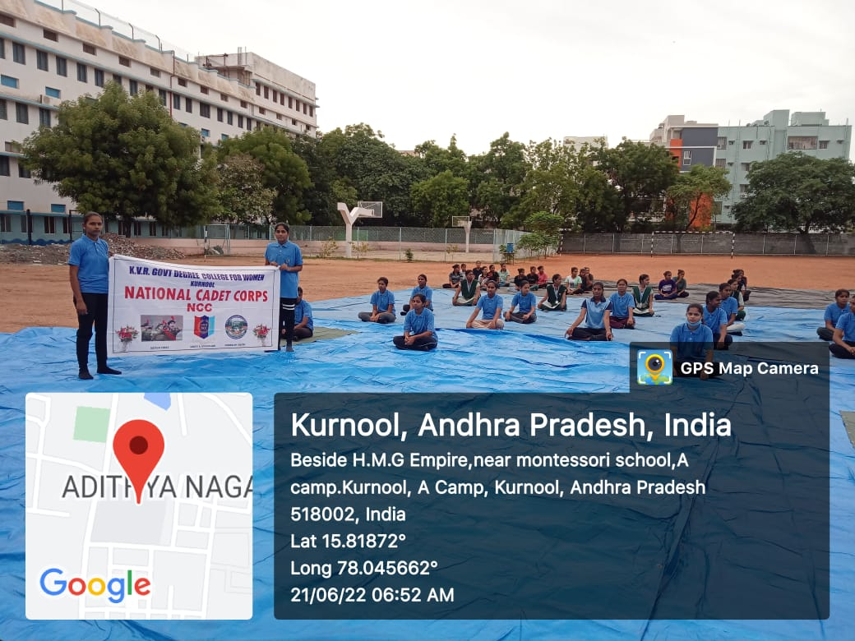

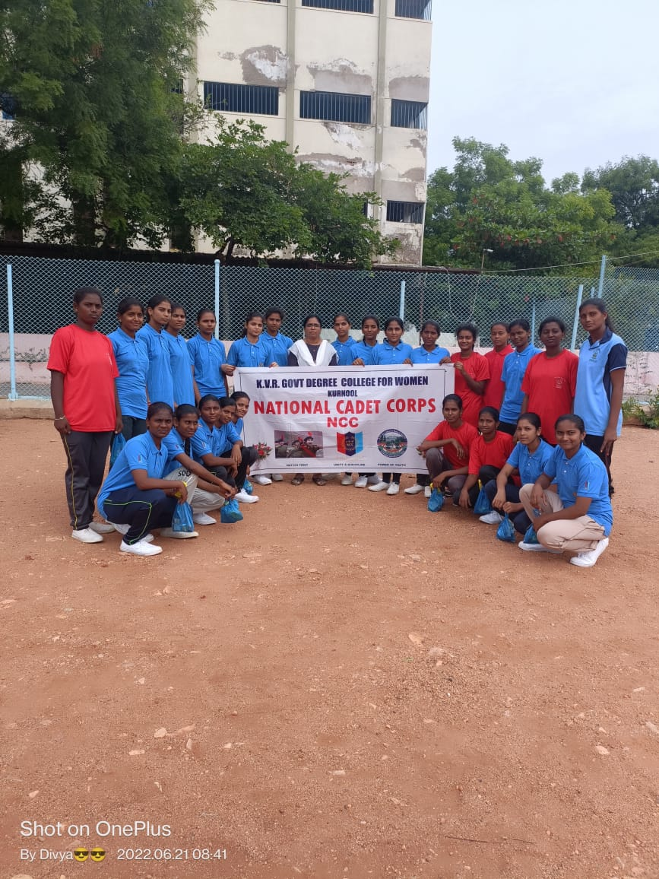

**Brief Report :** Yoga Day was celebrated at Montessori School ,A Camp, Kurnool . The programme was organized by 9 (An) Girls Battalion .Commanding officer ,AO ,ANOS, PI Staff,and the cadets of various institutions took part in the programme.

**Outcome:** NCC Cadets and other students came to know the importance of Yoga.

**K.V.R Govt. College for Women (A) ,NCC Activities 2022-23**

**AZADI KA AMRITH MAHOSTAV-RALLY**



**Date :** 2.08.22

**Name of the Participants :** Principal,Staff & Students

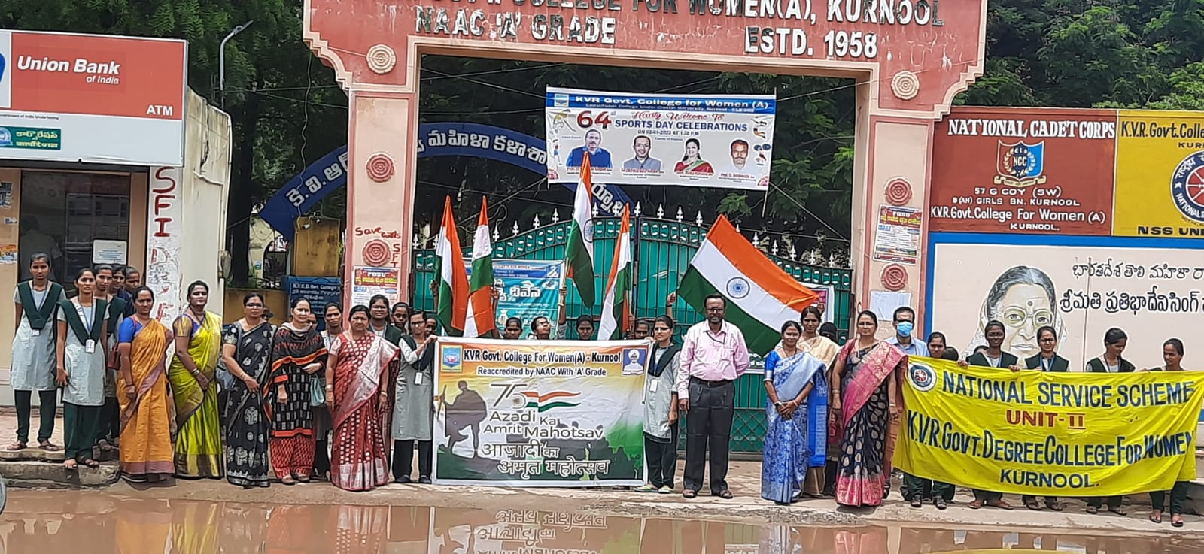

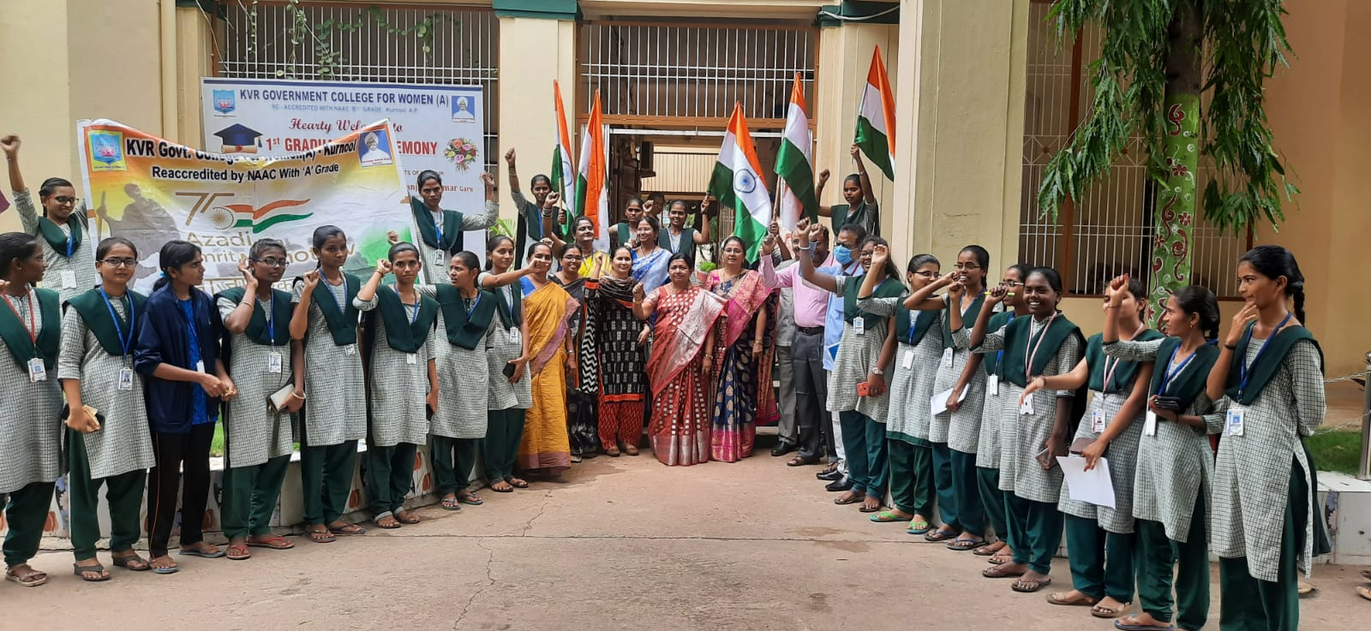

**Brief Report :** Staff and students of K.V.R.Govt.College for women have participated in Azadi ka Amrith Mahostav Rally conducted by Dept.of History,NCC & NSS units of the college.

**Outcome:** NCC Cadets and other students came to know the importance of the Independence and the

Sacrifices done by the great heroes of our nation.

**K.V.R Govt. College for Women (A) ,NCC Activities 2022-23**

**AZADI KA AMRITH MAHOSTAV-BICYCLE RALLY**



**Date :** 2.08.22

**Name of the Participants :** Principal,Staff & Students

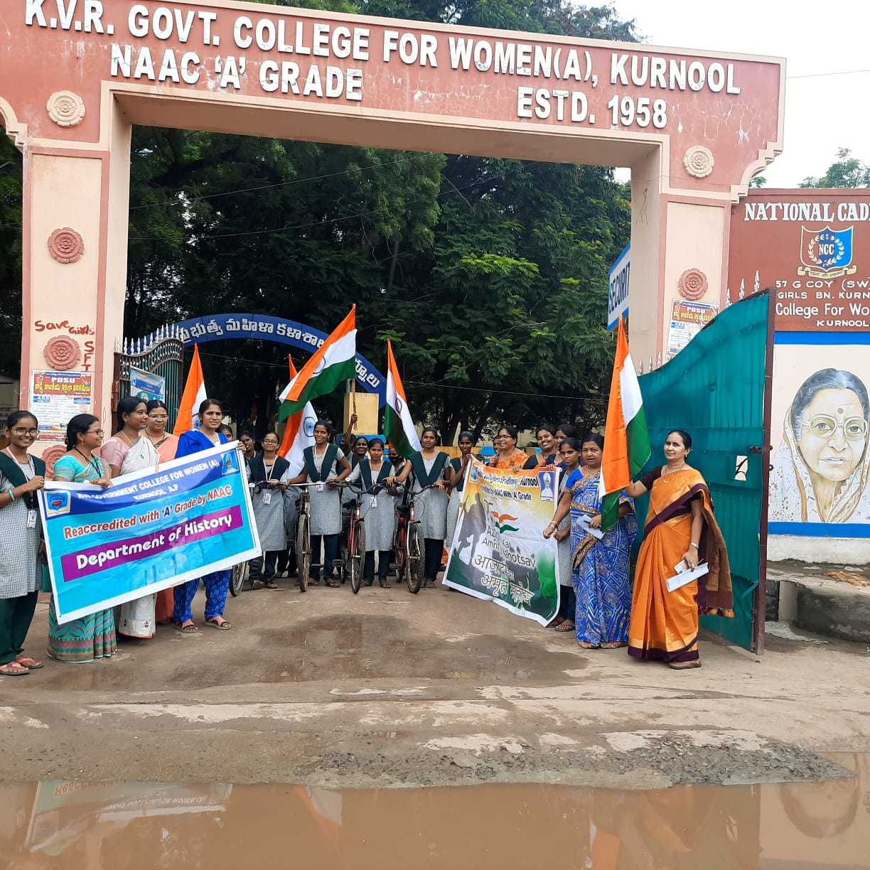

**Brief Report :** Staff and students of K.V.R.Govt.College for women have participated in Azadi ka Amrith Mahostav Bicycle Rally conducted by Dept.of History,NCC & NSS units of the college.

**Outcome:** NCC Cadets and other students came to know the importance of the Independence and the

Sacrifices done by the great heroes of our nation.

**K.V.R Govt. College for Women (A) ,NCC Activities 2022-23**

**AZADI KA AMRITH MAHOSTAV-ESSAY WRITING& SINGING COMPETITIONS**



**Date :** 8.08.22

**Name of the Participants :** Principal,Staff & Students

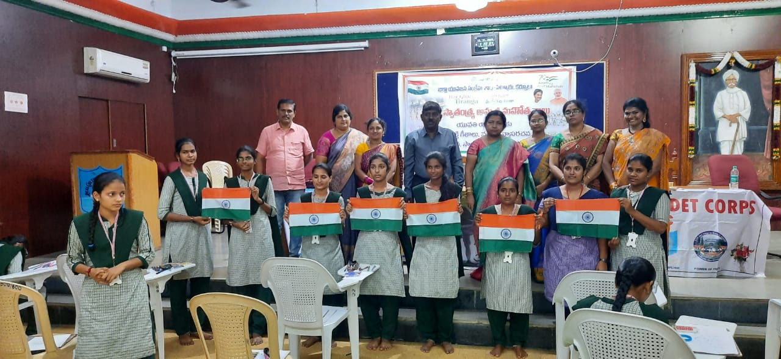 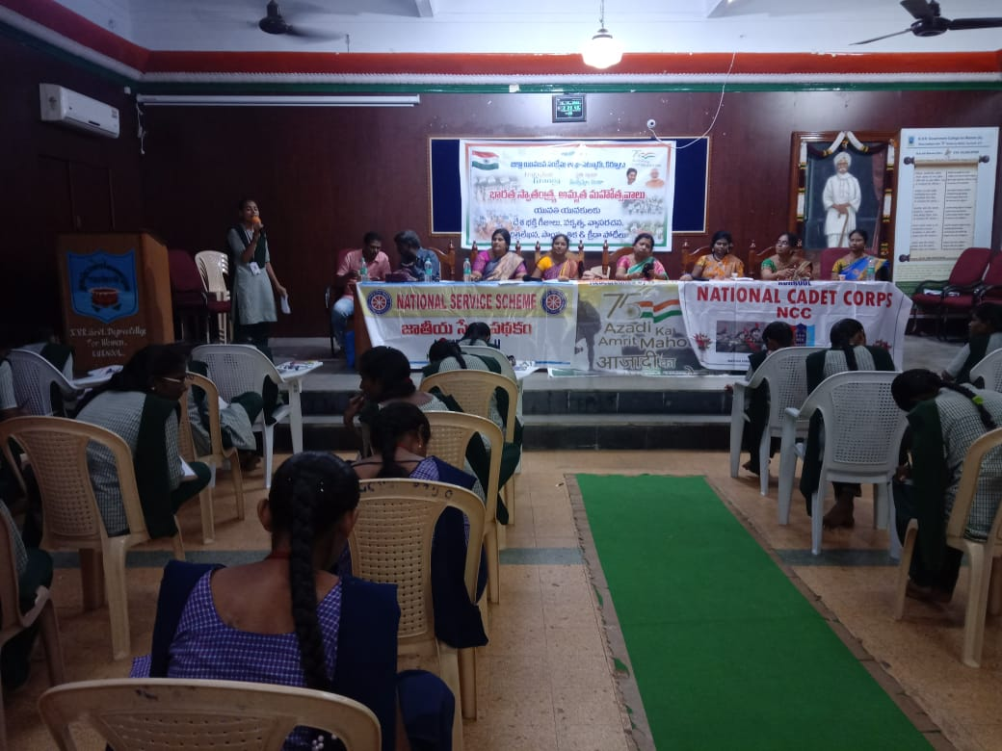

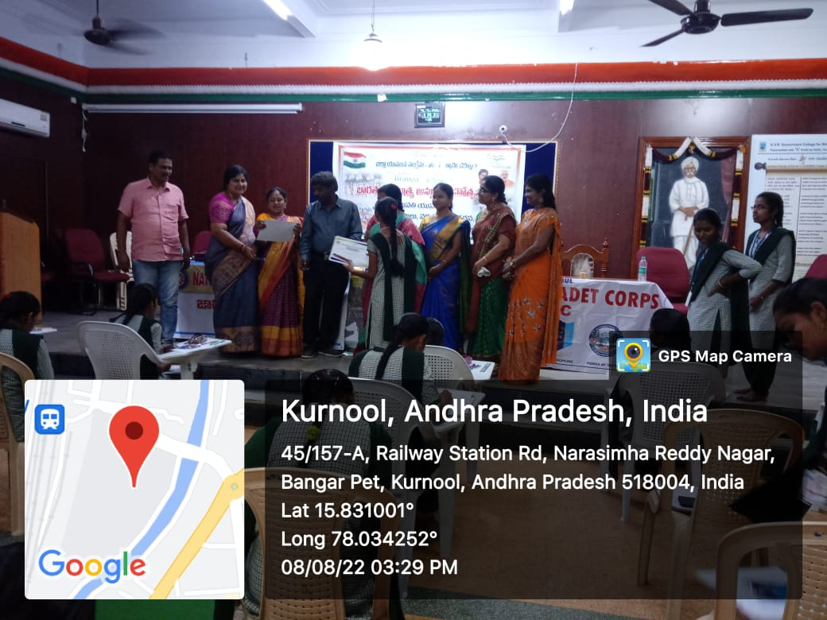

**Brief Report :** Staff and students of K.V.R.Govt.College for women have participated in Azadi ka Amrith Mahostav programme conducted by NCC & NSS units of the college.As part of this programme with the support of SETKUR , singing and Essay writing competitions were conducted.

**Outcome:** NCC Cadets and other students took part in the programme with great enthusiasm and participated in the events and bagged prizes sponsored by SETKUR.

**K.V.R Govt. College for Women (A) ,NCC Activities 2022-23**

**AZADI KA AMRITH MAHOSTAV-BICYCLE RALLY**



**Date :** 11.08.22

**Name of the Participants :** Group Commander,Commanding officers,ANOS,PI Staff &Cadets

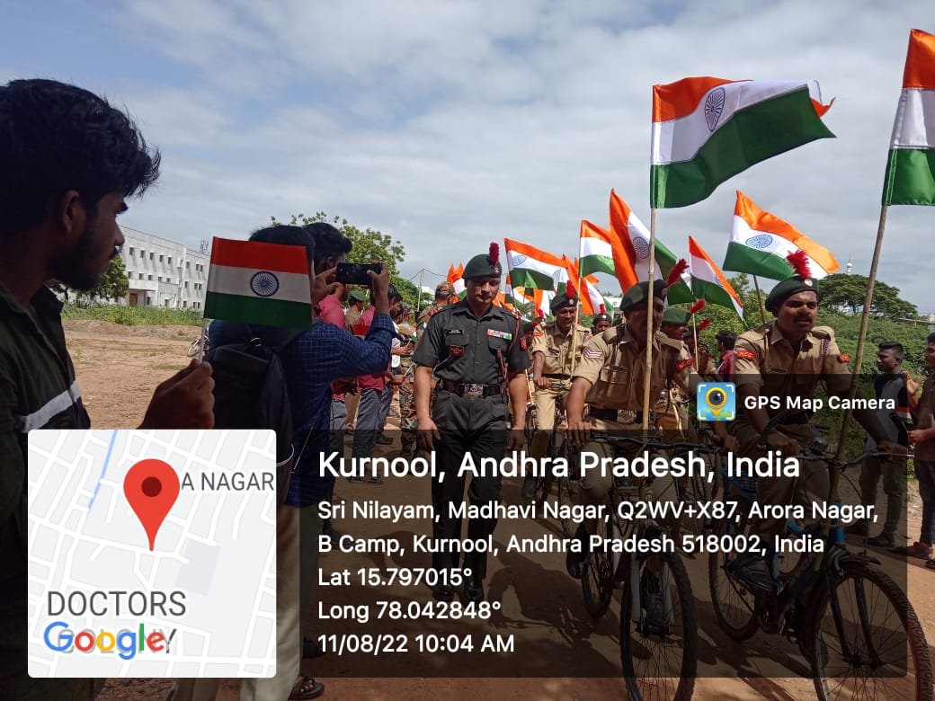

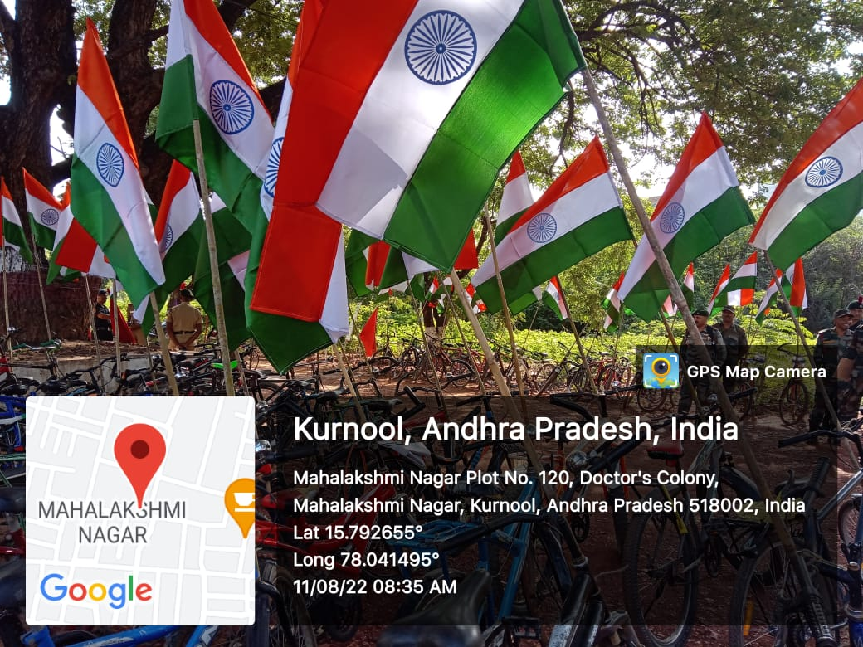

**Brief Report :** NCC Cadets of various institutions have participated in Azadi

ka Amrith Mahostav Bicycle Rally conducted by 9 (An) Girls Battalion & 28 (An) Boys Battalion . Group Commander , commanding officers , ANOS & PI staff participated in the programme.The rally started from Group Head Quarters to C-camp-Gayathri estates and ended at Men’s College.

**Outcome:** NCC Cadets and other students came to know the importance of the Independence and the

Sacrifices done by the great heroes of our nation.

**K.V.R Govt. College for Women (A) ,NCC Activities 2022-23**

**INDEPENDENCE DAY CELEBRATIONS**



**Date :** 15.08.22

**Name of the Participants :** Principal,Staff & NCC Caets & Students

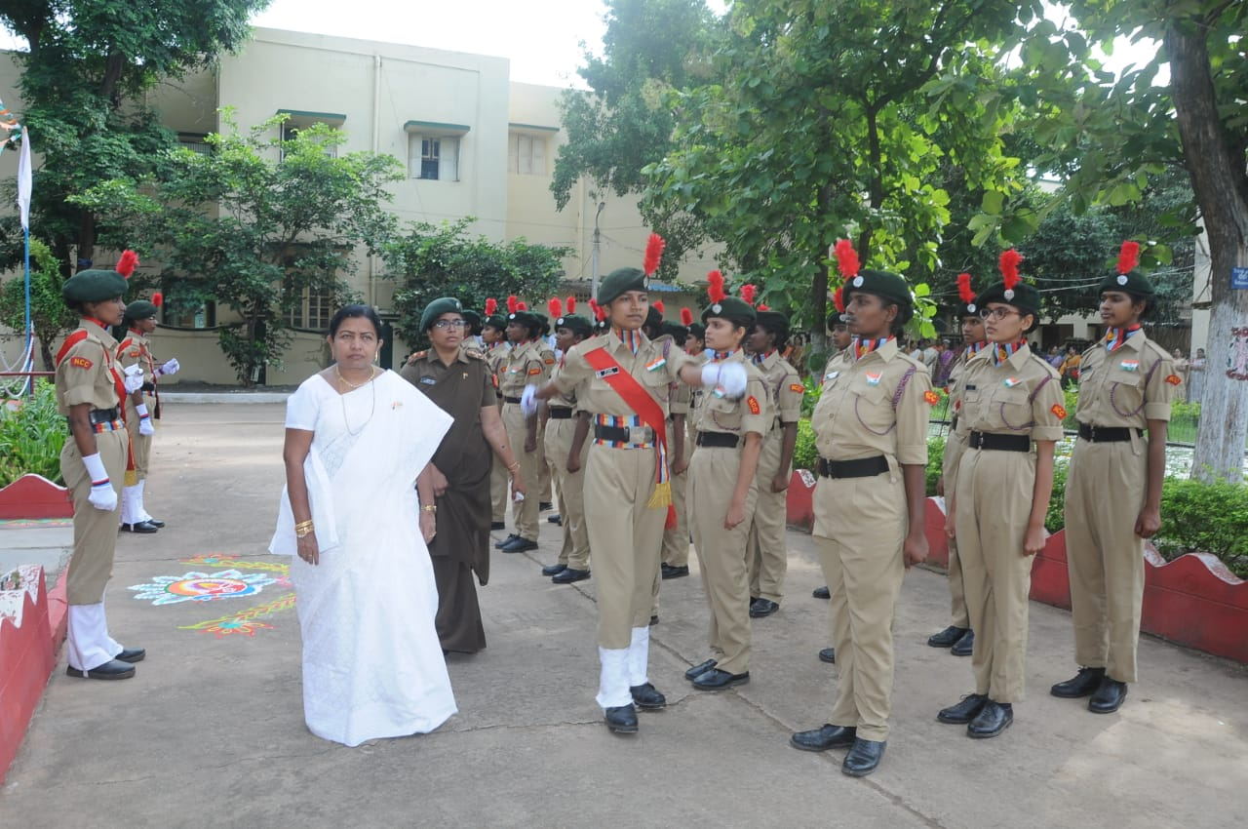

**Brief Report :** INDEPENDENCE DAY was celebrated on the campus of K.V.R.College with great enthusiasm and patriotic fervor.

**Outcome:** Principal Dr.M.Indira Shanthi Garu , Lecturers ,NCC Officer ,NCC Cadets and other students have participated in INDEPENENCE DAY celebratons .NCC Cadets performed Drill and gave Guard of Honour.